English
This term Year 4 will be studying the picture book ‘Quest’, ‘The Ice Kingdom’, the opening chapter of ‘Harry Potter’, and a children’s graphic novel adaptation of Charles Dickens’ ‘Great Expectations’. We will be learning about and have opportunities to write interesting openers to a story, story maps, diary entries, play scripts, descriptions to create atmosphere in a scene, and using pictures to retell a story.

The children will continue to improve their reading and comprehension skills, as well as practising their joined up cursive handwriting, to try and earn a pen license if they don’t already have one.

R.E.
This term we will be looking at the question ‘Why do some people think life is a journey?’ looking at different ceremonies relating to Christians, Hindus and Jews.

Science
In science, we will be studying living things and their habitats. We will be looking at different ways of grouping living things and using classification keys to name them. We will also be learning that environments can change and the negative impact this can have. We will also be studying electricity. We will be looking at different electrical appliances and seeing if they use batteries or mains power to work. We will be investigating how electrical circuits work.

French
This term, the children will be continuing to learn French. They will be learning how to say the names of different colours and clothing items in French, as well as giving descriptions.

Topic
(Geography, History, Art and D.T.)

Year 4’s History topic this term will be based on the Victorians. We will be learning about Victorian ways of life, including school, jobs and toys, and seeing how these differ to our lives now. We will also be looking at how inventions and technology changed throughout the Victorian era.
Our Geography will be focused on the Arctic and Antarctica, starting by looking at maps of the world to identify the equator, the northern and southern hemispheres and lines of latitude and longitude. We will then look at the Arctic and Antarctic Circles in more detail, comparing the climate and physical features between there and the UK.
This term, in D.T., we will be linking with our Science work to produce a Christmas scene that lights up. The children will also be studying Paul Klee in Art.

Year 4
Autumn Term
Victorious Victorians

Maths
To start the term, we will be learning about place value. We will be partitioning numbers up to 1000 as well as representing these accurately on a number line. We will be learning Roman numerals and how to round numbers to the nearest 10, 100 and 1000. We will then be moving on to addition and subtraction, learning how to add and subtract efficiently numbers with up to 4-digits, as well as learning the inverse, estimating and different strategies to check our answers. We will then be starting our multiplication and division topic, focusing on times tables and the related division facts. We will also be learning what happens when we multiply by 0 and 1, as well as how to multiply 3 numbers together. The children will also be learning how to calculate the area of shapes. The children will be continuing with their times tables, recapping the 3x, 4x and 8x, before moving on to the 6x, 7x, 9x, 11x and 12x tables.

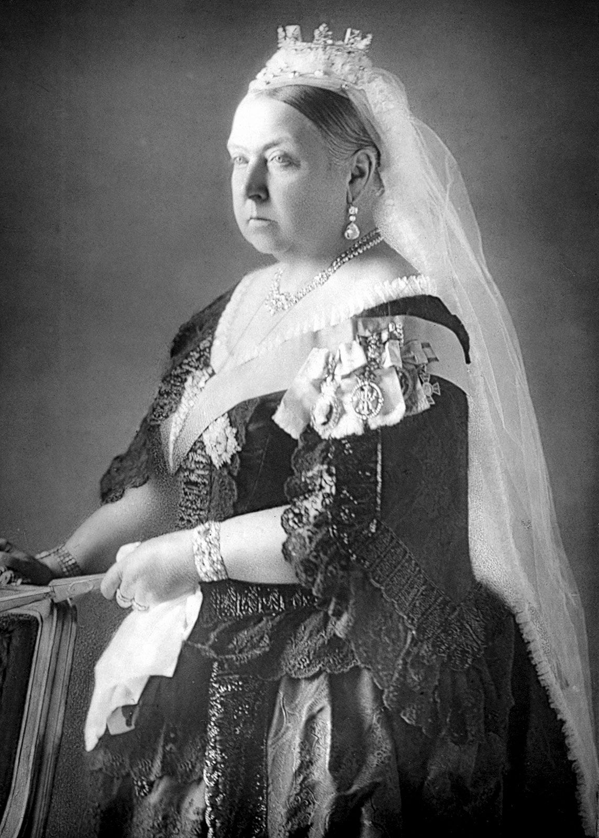

P.E.
During the autumn term, all the children will be improving their team work and ball control skills in football and Tag Rugby, as well as continuing with their swimming lessons.

P.E. Days – Tuesdays (Swimming) and Wednesdays (which will be outside) – please make sure P.E. kits are in school on these days and that earrings are removed for P.E. Children may wear jogging bottoms/leggings, sweatshirts/hoodies and trainers for outdoor P.E. lessons, but will still need their shorts and t-shirts in school.

We hope you all had a good summer. Homework grids will be given out this Friday. Weekly homework for each week will be given out on Fridays and should be handed in by the following Tuesday. Spellings will be tested on a Friday and times tables will be tested on Tuesdays. All children should be reading at least 3 times a week at home.

Music
The children will be working in groups to learn how to work collaboratively together. They will also be singing their songs for the Christmas concert, where they will be practising singing in time and to the correct tune with the music.
Please look out for song words being given out near the end of October.

Computing
The children will continue to practise their touch typing throughout the term. They will also be learning about what coding is and starting to programme simple instructions, as well as recognising how technology can help us work collaboratively.

Class Teacher: Mrs Sherwood (Swans)
Miss Hart (Flamingos) Miss Taplin (Owls)

Please come and see us if you have any questions.

PP.H.S.E.
Year 4 will be learning about the topic of family and relationships. We will be looking at bullying, stereotypes and how our behaviour affects others. We will also be learning about respect, manners and healthy friendships. We will also be learning about health and wellbeing. We will be looking at why it is important to keep our teeth clean, as well as discussing our emotions. We will also be learning about why it is important to make mistakes and what we can do to relax.

