Falcon Class - Challenge Homework Spring 1 – The Rotten Romans

Please note: At least one Maths (Mymaths) and one EGPS (Education City) homework assignments must be completed each week in addition to the regular weekly homework (Please see below). Weekly tasks will be set each Thursday and should be completed by the following Tuesday. If you are not able to access a computer at home, please contact me ASAP. You can then also choose to complete any of the other tasks set below. Should weekly homework not be completed, time will be provided, during lunch breaks, in school for your child to complete the Maths or Reading tasks. Any challenge homework tasks must be completed by Tuesday 11th February 2025

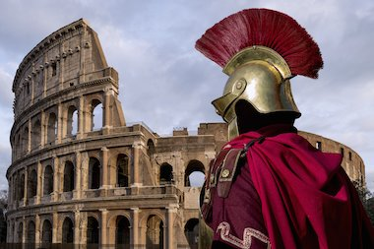 | Regular Weekly Homework: Reading, Spellings, Times Tables  Reminder: Copies of spelling sheets and times tables can be found on our Class web page and on Class Dojo.  Topic-Linked Homework: You are aiming to complete enough activities to earn a minimum of 30 Dojos. Each Task is worth 5 dojos, unless stated otherwise. Please complete challenge tasks in pencil or handwriting pen (if you have a pen license).
 | Knowledge and Understanding | Applying and Analysing | Creating and Evaluating
Communication and Literacy  (Reading, Writing and Speaking) | EGPS Activity  EGPS tasks set weekly on Education City. 5 dojo points will be rewarded for activities that score 70% or above. |  | Reading Comprehension  Reading comprehension tasks set weekly. Please ask a Year 4 adult for the sheet. An extra 5 points will be awarded if you complete the Grammar and All About Words sections.
Logical, Reasoning and Mathematical  (Science and Maths) | My Maths  Please login into your My Maths account to see the weekly tasks. 5 dojo points will be rewarded for activities that score 70% or above (or activities that score lower than that if they have been attempted at least 3 times).  www.mymaths.co.uk |  | Sound (Science)  This term’s topic is Sound. Create your own musical instrument. Can you think about what allows it to make its sound?
Visual/ Spatial/ Kinesthetic  (Creative Arts) | History  Create a project about the Romans. You could focus on one topic or include a few different ones. You can design your project however you like (poster, PowerPoint, fact file, leaflet, model with labels etc). Remember to research your chosen topic first. | Art  Create your own Roman mosiac. What materials could you use? Be as creative as you like. | PSHE  Think about how you can protect the environment by using things which would normally be thrown away. Can you make a pair of shorts out of old trousers? Can you make a bird feeder out of a milk carton? Come up with an idea and bring your new creation into school.
School Value (Independence) and Growth Mindset | To make yourself more independent at home (and to help with your trip to Bowles), learn how to put on a pillowcase and duvet cover to make your bed. Show photos of your progress. We will also have another practice near the end of term (date tbc) for you to show your new skills!
OWN TASK: Earn up to an additional 10 dojo points for a task of your choice related to the topics we are covering in class this term.

