English
This term Year 4 will be reading ‘Escape from Pompeii’ and a selection of Roman Myths and Legends. We will be retelling stories and poems, as well as writing a nonchronological report and a newspaper report.

The children will continue to improve their reading and comprehension skills, developing strategies to help them with different types of question. They will also continue practising their joined up cursive handwriting, to try and earn a pen license if they don’t already have one.

R.E.
0ur key question is ‘What do different people believe about God. We will be focusing on the views held by Hindus & Humanists

Science
In science, we will be learning about sound, recognising how sounds are made and finding patterns between the pitch and volume of sounds. We will also be starting our animals including humans topic, looking at different food chains.
French
This term, the children will be continuing to learn French. They will be learning about French food as well as learning how to talk about music.

Year 4 Spring 2025
The Rotten Romans

Topic
(Geography, History, Art and D.T.)
Throughout the Spring term our topic will be based on the Romans and Italy.
In history we will be learning about Roman ways of life, including food, jobs and leisure activities, as well as how the Roman Empire was formed. In geography we will also be studying Italy and comparing the country with the UK.

In Art, we will be designing and making our own Roman mosaics and in DT we will be looking at Italian foods and preparing some of our own Italian dishes!

Maths
This term we will be continuing our multiplication and division topic, learning how to multiply and divide by 10 and 100, as well as formal written methods to multiply and divide 2 and 3-digit numbers. We will also start our fractions and decimals topics, learning how to compare and convert fractions, add and subtract fractions and divide numbers to give a decimal as the answer. We will also be learning how to calculate the perimeter of different shapes. The children will continue to practise their times tables up to 12x12.

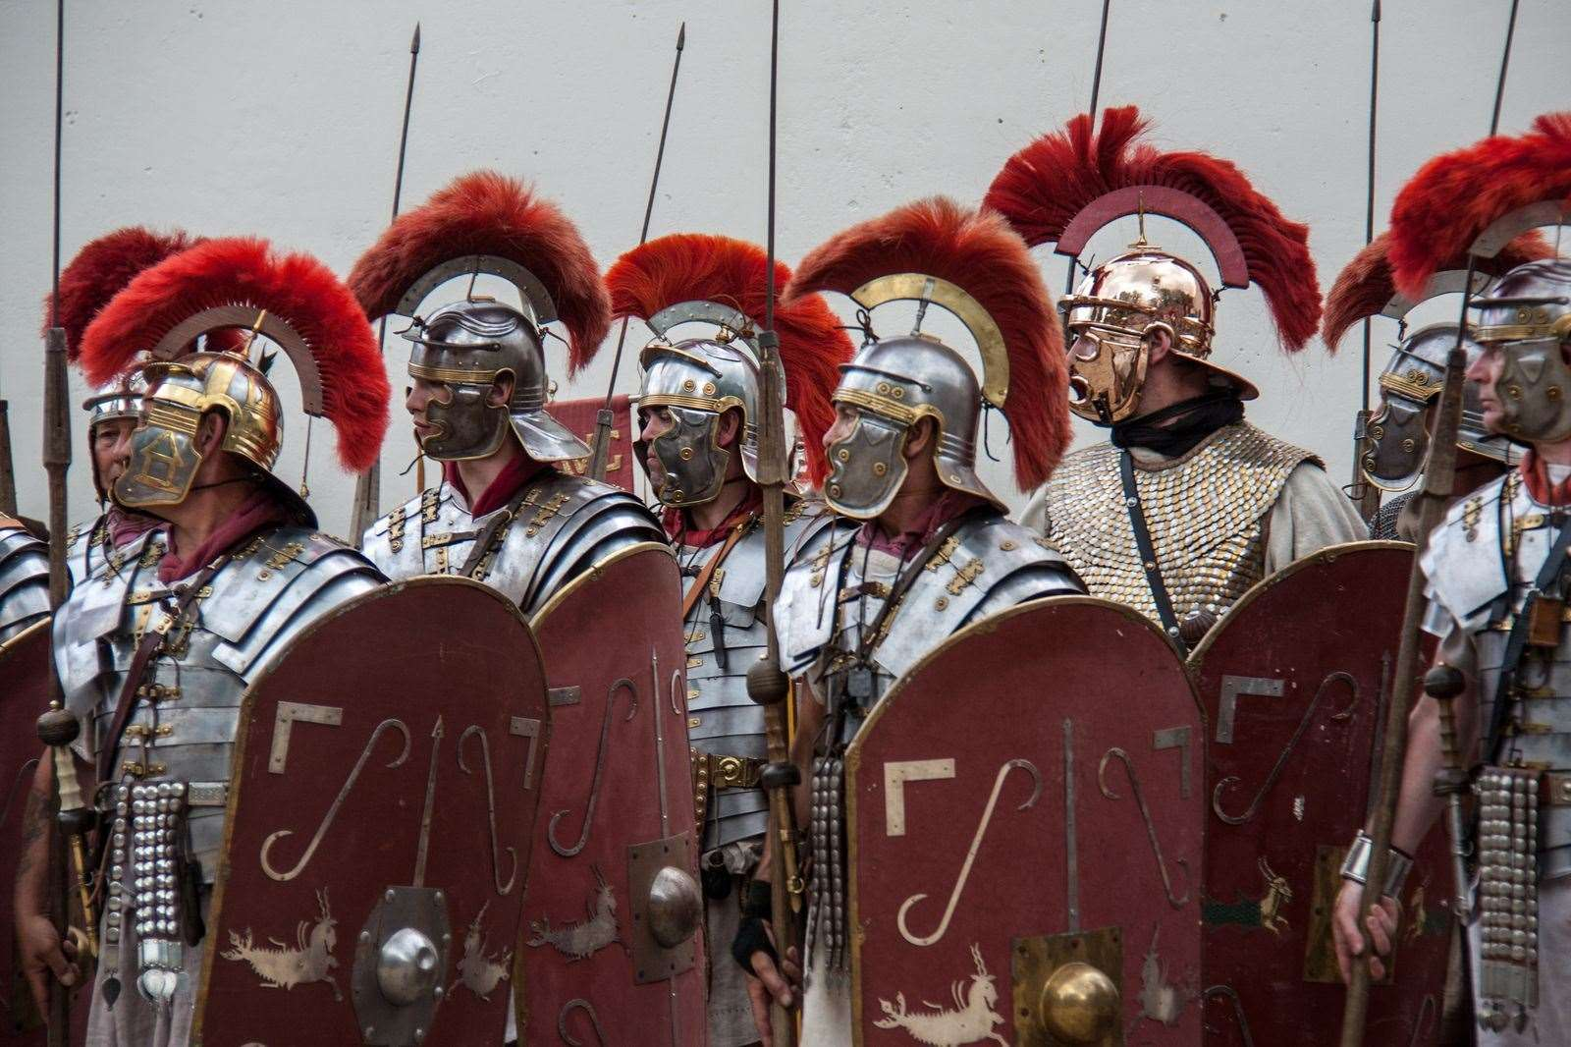

P.E.
During spring term 1, both of our PE sessions will be inside. The children will be improving their balance and coordination skills in gymnastic and dance, as well as practising their hand-eye co-ordination and ball skills in Hockey and Tennis in Spring term 2.

P.E. Days – Tuesday and Wednesdays – please make that earrings are removed for P.E. or taped over with medical tape.
Children will need to wear their black shorts and white t-shirts for indoor P.E. lessons, can children please wear these underneath their jogging bottoms and jumpers on a Tuesday and Wednesday.

Happy New Year!
We hope you had a lovely Christmas and thank you for all our lovely presents and cards.
Homework for each week should be handed in by the following Tuesday. Spellings will be tested on a Friday and times tables will be tested on Wednesdays. All children should be reading at least 3 times a week at home. We are all looking forward to the Year 4 residential trip to Bowles Monday 3rd - Wednesday 5th February 2025

Computing
The children will continue to practise their touch typing throughout the term. They will also be learning how to design a web site as well as learning how computer systems work.

Class Teacher: Mrs Sherwood (Swans)
Miss Hart (Flamingos) Miss Taplin (Owls)

Please come and see us if you have any questions.

PP.H.S.E.
Year 4 will be learning about citizenship, seeing how community groups can be beneficial and what we can do to protect the environment.
We will also be learning about economics. We will be looking at budgeting and what makes something good value for money, as well as recognising different ways you might lose money.
Music
We will be learning how to sing in tune and time and to understand a musical motif. We will then move on to composing and developing our own musical motifs.

- To develop a musical motif
put actions to music as well as independently playing some music as part of a larger group piece.

