

**Crockenhill**

**Primary School**

**Collective Worship Policy**

**Reviewed July 2025**

**Collective Acts of Worship Policy**

The Collective Worship Policy at Crockenhill Primary School pays due regard to statutory requirements, and has taken account of the guidance offered by the Kent Local Authority through its SACRE.

In line with the 1988 Education Reform Act and the 1996 education Act, which states that collective worship should be **‘wholly or mainly of a broadly Christian character’**, and in recognition of our pupils that are practising members of other faiths, we base our assemblies on those aspects of Christian teaching that are shared with other faiths.

The Collective Worship Policy of Crockenhill Primary School is consistent with the philosophy, values and ethos of the school. Assemblies are conducted in a manner that is sensitive to the individual faiths and beliefs of all members of the school.

# Definition of Collective Worship

Collective Worship is a time when the whole school, or groups within the school meet together in order to consider and reflect on common concerns, issues and interests. It offers all pupils an opportunity to worship through engaging in relevant, meaningful experiences and provides opportunities for the pupils’ spiritual, moral, social and cultural development.

**Aims of Collective Worship**

# For the School

Collective Worship contributes significantly to the ethos of Crockenhill Primary School and it is our aim that we:

* share common aims and values
* celebrate achievement and special times

* explore together the world in which we live

* develop a community spirit

# For the Pupils

We also intend that Collective Worship contribute to the development of the pupil as a ‘whole’ person by providing *opportunities* to:

* worship
* reflect on that which is considered worthy

* consider spiritual and moral issues

* explore their own beliefs

* develop their own spirituality

* reflect on the direction of their lives

* reinforce positive attitudes

* participate and respond
* reflect on what it means to be human
* consider the wonders and worries of the world

## The Contribution of Collective Worship to aspects of the Curriculum

Collective Worship time is distinct from curriculum time. However, at Crockenhill, Collective Worship will at times feature aspects of the curriculum, which will enhance the experiences of pupils by reflecting on the work completed in class.

Additionally, it will enrich classwork through its consideration of subject matter from different perspectives. The provision of opportunities for pupils’ spiritual, moral, social and cultural development is in line with school policy, which informs our practice. To ensure Collective Worship provides opportunities for spiritual, moral, social and cultural development, it will address a wide variety of themes and topics use diverse stimuli and resources and provide pupils with the opportunity to ‘respond’ on their own level.

**The Management of Collective Worship**

The Humanities Curriculum Team will plan, monitor and evaluate acts of Collective Worship.

## The Organisation of Collective Worship

Collective Worship is organised to provide a variety of groupings and will take place in the school hall or the classroom. Collective acts of worship are incorporated into whole school assemblies, class based collective worship and RE lessons.

At Crockenhill Primary School, we follow a Collective Worship Annual Plan.

*“Collective worship and assembly Collective worship and assembly are distinct activities, although they may take place as part of the same gathering. Collective worship is a special time for pupils to reflect upon life experiences and ultimate questions and, if appropriate, focus on God. It should allow the pupils to be able to make a spiritual response…Schools often gather for achievement assemblies, singing assemblies and curriculum assemblies. These can be made into an act of collective worship through the addition of an opportunity for reflection or prayer at the end of these times. Without it they stay as an assembly.”*

**Monday** - Whole School – A focus on British Values, school values, world and current events

**Tuesday** - Key Stage – A focus on key events, religious celebrations, key individuals and current affairs to develop SMSC

**Wednesday** - Class based reflection

**Thursday** - Whole School – alternating weeks of singing and reflection and a collective worship led by a visiting Pastor from one of the community churches

Friday – Whole School – a chance to reflect and celebrate on the events and achievements of the week

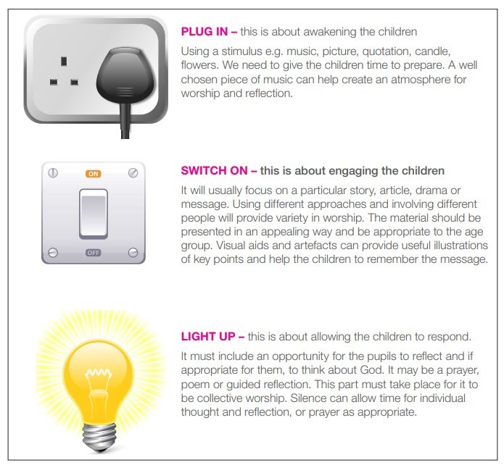

This format is based on one produced by Blackburn Diocese.

Note: It is common for schools to combine an assembly and collective worship. In this case, the ‘Plug in’ and ‘Switch on’ parts may be regarded as part of the assembly. The act of collective worship is the ‘Light up’ aspect.

## Leadership

Every member of the teaching staff (except ECTs in their first year), SLT and occasional visitors will be involved in leading acts of worship at some point in the school year.

## Planning Acts of Collective Worship

The content of all acts of Collective Worship will be considered carefully, to ensure relevance and suitability for the ages, aptitudes and backgrounds of all pupils.

Termly assembly rotas including a range of themes, special occasions and events will be followed, but will be flexible to allow the inclusion of current and topical issues.

## The Act of Collective Worship

A variety of teaching and learning styles and active and interactive methods are appropriate in acts of Collective Worship. Any and all of the methods employed in the classroom can be used effectively in acts of Collective Worship. A variety of resources will also be used. Leaders will choose the style/method and resources, which are appropriate to the content, the age, aptitude and the background of the pupils.

The content and process must be sufficiently stimulating in order to evoke a response in the individual. This may not be visual, but opportunity must be given to express this response through reflection and / or prayer.

If announcements are to be given at the same time as an act of worship then they will be of a positive nature, which at times may enhance the act of worship itself. Announcements will be made preceding the act of worship and a clearly defined break between them and the act of worship will be made.

## Withdrawal

Our assemblies will be conducted in a manner that is sensitive and inclusive to ensure that all children feel comfortable to attend the assembly.

Policy to be reviewed annually

**Appendix 1**

**Assembly Overview 2025-2026**

|  |  |  |  |  |  |
| --- | --- | --- | --- | --- | --- |
|  | **September** | **October** | **November** | **December** | **January** |
| **Monday** | School value:  **Co-operation**  British Value:  **Democracy** | School value:  **Co-operation**  British Value:  **Rule of Law** | School value:  **Perseverance**  British Value  **Parliament Week (all values)** | School value:  **Perseverance**  British Value:  **Individual Liberty** | School value:  **Independence**  British Value:  **Mutual Respect** |
| **Tuesday**  **(Alternate weeks phase assemblies)** | New beginnings  National Literacy Day  International Day of Peace  Recycling Week  Yom Kippur | Black History Month  National Poetry Day  World Mental Health Day  World Food Day | Remembrance  Guy Fawkes  Diwali  Anti-bullying week  Road safety  Children in Need | Advent  Christmas  Volunteers Day  Hannukah | New Year’s Resolutions  World Braille Day  Martin Luther King Day  Winnie the Pooh Day  Burns Night  National Storytelling Week |
| **Wednesday**  (Class based collective worship based on topical events) |  |  |  |  |  |
| **Thursday** | Alternate weeks singing and Pastor Mark.  Singing focus - Harvest | Alternate weeks singing and Pastor Mark.  Singing focus – Harvest/Remembrance | Alternate weeks singing and Pastor Mark.  Singing focus – Remembrance / Christmas | Alternate weeks singing and Pastor Mark.  Singing focus – Remembrance / Christmas | Alternate weeks singing and Pastor Mark.  Singing focus –  Topical |
| **Friday** | Weekly Celebration Assembly | Weekly Celebration Assembly | Weekly Celebration Assembly | Weekly Celebration Assembly | Weekly Celebration Assembly |

|  |  |  |  |  |  |  |
| --- | --- | --- | --- | --- | --- | --- |
|  | **February** | **March** | **April** | **May** | **June** | **July** |
| **Monday** | School value:  **Independence**  British Value:  **Tolerance** | School value:  **Motivation**  British Value:  **Democracy** | School value:  **Creativity**  British Value:  **Rule of Law** | School value:  **Creativity**  British Value:  **Individual Liberty** | School value:  **Aspiration**  British Value:  **Mutual Respect** | School value:  **Aspiration**  British Value:  **Tolerance** |
| **Tuesday**  **(Alternate weeks phase assemblies)** | Rosa Parks Day  LGBQT+ history month  Time to Talk  Chinese New Year  Kindness Day | World Book Day  St David’s Day  Ramadan  British Science Week  Holi  Easter | Eid-al-Fitr  Vaisakhi  World Heritage Day  Saint Georges Day  Dance Day | Vesak  May Day  VE Day  International Nurses Day  Walk to School Week | Environment Day  D-Day  World Ocean’s Day  World Refugee Day | Leavers Celebrations  NHS  Wimbledon  Moon landing |
| **Wednesday**  (Class based collective  worship based on topical events) |  |  |  |  |  |  |
| **Thursday** | Alternate weeks singing and Pastor Mark.  Singing focus - Easter | Alternate weeks singing and Pastor Mark.  Singing focus - Easter | Alternate weeks singing and Pastor Mark.  Singing focus - Spring | Alternate weeks singing and Pastor Mark.  Singing focus – Spring | Alternate weeks singing and Pastor Mark.  Singing focus – summer | Alternate weeks singing and Pastor Mark.  Singing focus – End of year |
| **Friday** | Weekly Celebration Assembly | Weekly Celebration Assembly | Weekly Celebration Assembly | Weekly Celebration Assembly | Weekly Celebration Assembly | Weekly Celebration Assembly |