Test on 27/2/2026 | Test on 6/3/2026 | Test on 13/3/2026
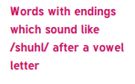  Official  Special  Artificial  Social  Racial  Crucial  Facial  Beneficial  Superficial  Antisocial | 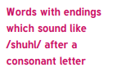  Partial  Confidential  Essential  Substantial  Torrential  Sequential  Potential  Spatial  Martial  Influential | 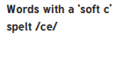  Cemetery  Certificate  Celebrate  Necessary  Deceased  December  Sacrifice  Hindrance  Nuisance  Prejudice
Test on 20/3/2026 | Test on 27/3/2026 | Test on THURSDAY 2/4/2026
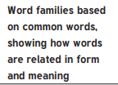  Accommodate  Accompany  Access  Accuse  Accost  Accrue  Accuracy  Accomplish  Accumulate  Accentuate | 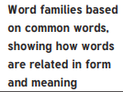  Signature  Assign  Design  Designate  Significant  Resignation  Resign  Insignificant  Assignment  Signal | Statutory Challenge Words  Foreign  Apparent  Appreciate  Persuade  Individual  Language  Sufficient  Determined  Explanation  Pronunciation
GROUP A – Spring 2
English Homework – complete each week’s task in your homework book and hand in each Tuesday.
Week 1: 26/2/2026
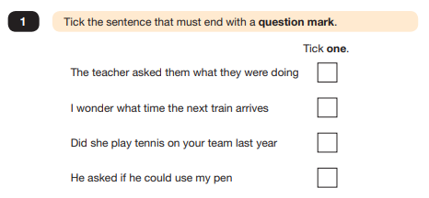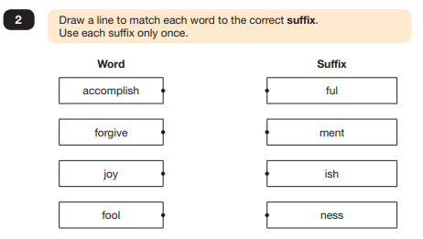

Week 2: 5/3/2026
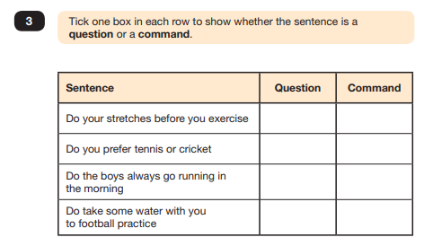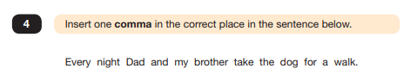
Week 3: 12/3/2026
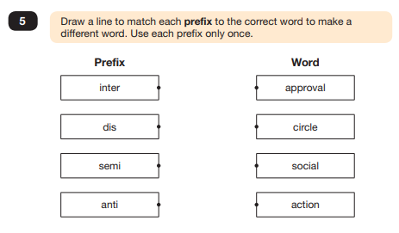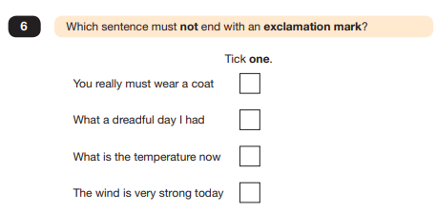
Week 4: 19/3/2026
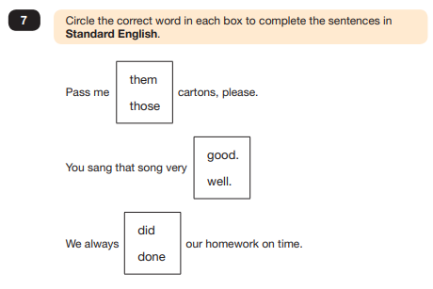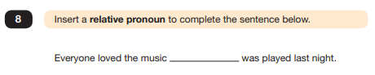

Week 5: 26/3/2026
