Year 6 Spring Term 2 Overview – Group C

Test on Friday 27.2.202 | Test on Friday 6.3.2026 | Test on Friday 13.3.2026 | Test on Friday 20.3.2026 | Test on Friday 27.3.2026 | Test on THURSDAY  2.4.2026

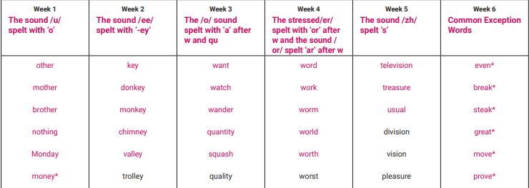

English Homework – complete each week’s task in your homework book and hand in each Tuesday.
Week 1: 26/2/2026
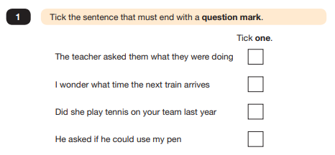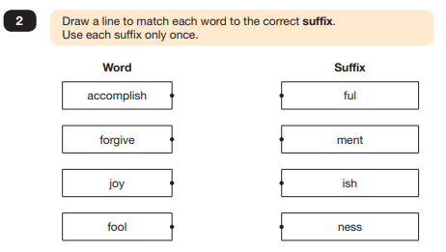
Week 2: 5/3/2026
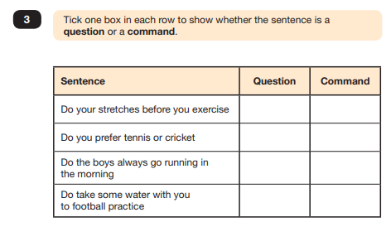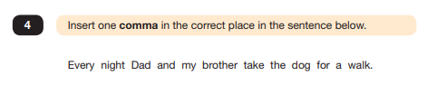
Week 3: 12/3/2026
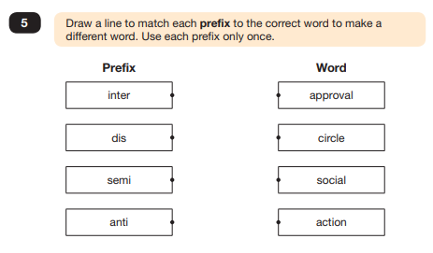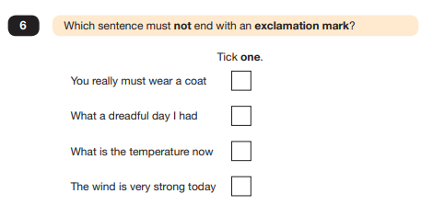

Week 4: 19/3/2026
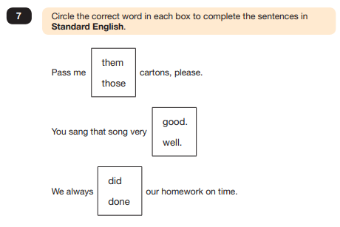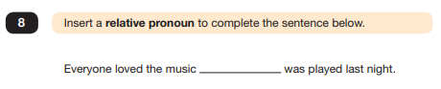
Week 5: 26/3/2026
