Test on 24/4/2026 | Test on 1/5/2026 | Test on 8/5/2026
Word families based on common words  programme  telegram  hologram  diagram  grammar  grammatical  parallelogram  monogram  programmer  program | Words that be nouns and verbs  challenge  protest  broadcast  benefit  charge  function  influence  interest  object  damage | Words that be nouns and verbs  produce  present  reason  silence  support  transport  surprise  scratch  freeze  balance
GROUP A – Summer 1
English Homework
Week 1: 23/4/2026
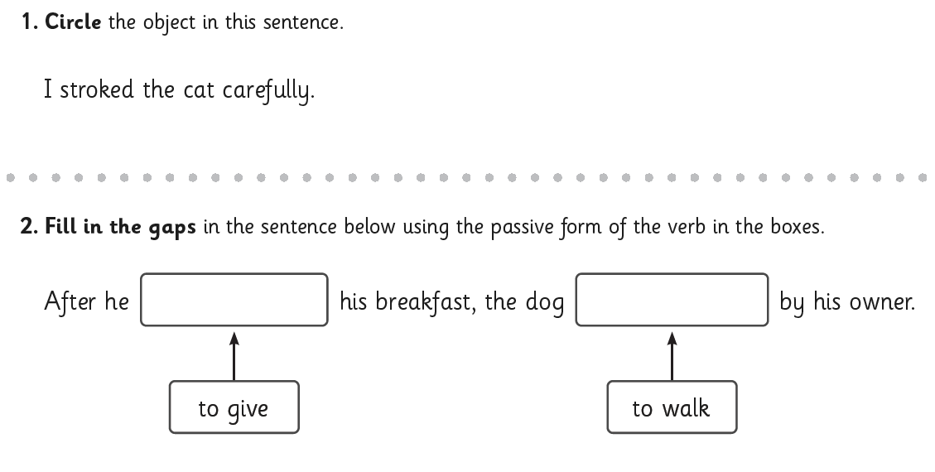
Week 2: 30/4/2026
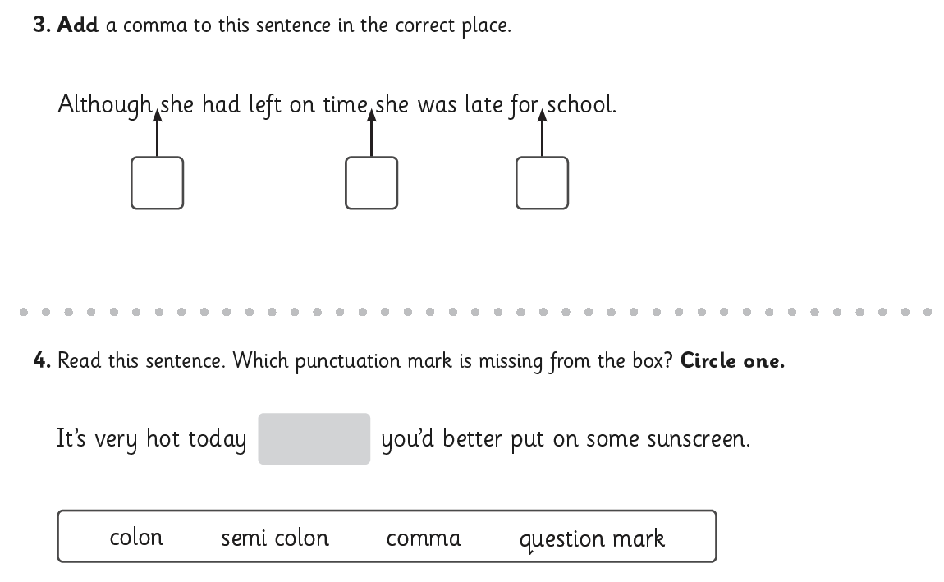

Week 3: 7/5/2026
