Test on 24/4/2026 | Test on 1/5/2026 | Test on 8/5/2026
Words with a short /u/ spelt with an o  woman  wonder  month  brother  above  Monday | Words with a short /u/ sound spelt with ou  Enough  young  touch  double  trouble | Words with a short /u/ sound spelt with ou  country  courage  rough  tough  cousin
GROUP C – Summer 1

Week 1: 23/4/2026
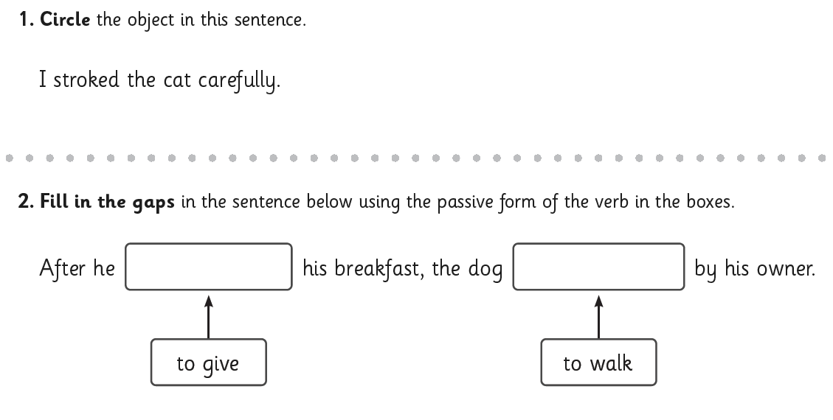
Week 2: 30/4/2026
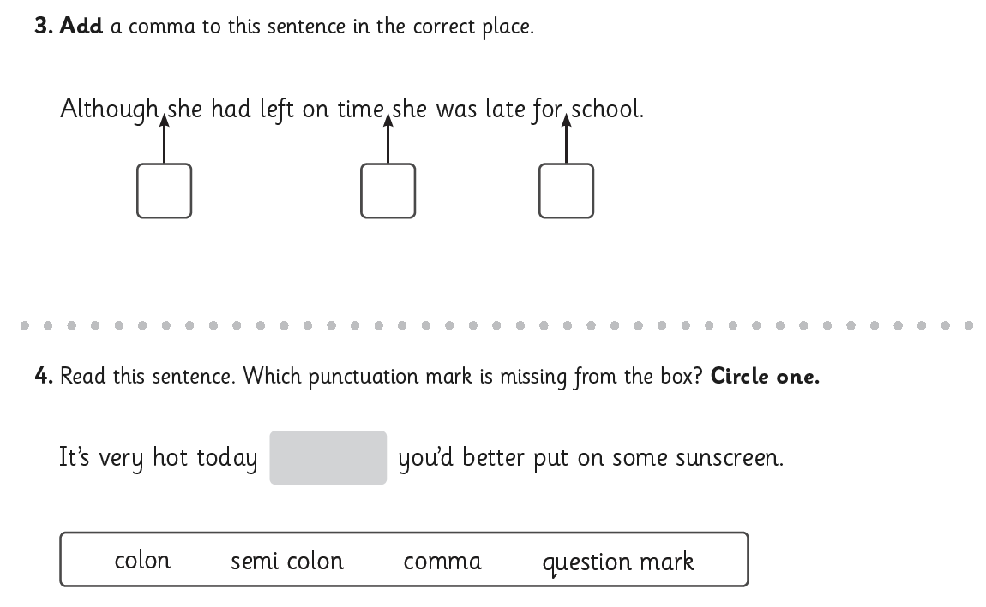

Week 3: 7/5/2026
