Test on 27/2/2026 | Test on 6/3/2026 | Test on 13/3/2026
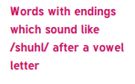  Special  Social  Racial  Crucial  Facial  Antisocial | 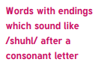  Partial  Essential  Torrential  Potential  Spatial  Influential | 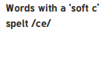  Cemetery  Certificate  Celebrate  Necessary  Sacrifice
Test on 20/3/2026 | Test on 27/3/2026 | Test on THURSDAY 2/4/2025
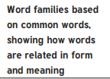  Access  Accuse  Accost  Accrue  Accuracy  Accomplish | 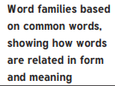  Signature  Design  Resignation  Resign  Insignificant  Signal | Statutory Challenge Words  Foreign  Apparent  Appreciate  Persuade  Individual  Language  Determined  Explanation
GROUP B – Spring 2
English Homework – complete each week’s task in your homework book and hand in each Tuesday.
Week 1: 26/2/2026
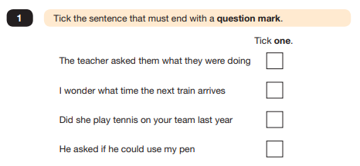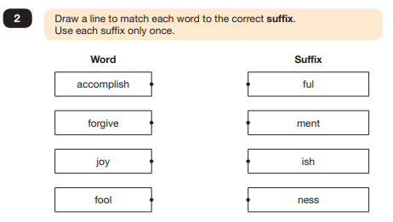
Week 2: 5/3/2026
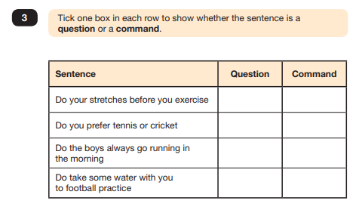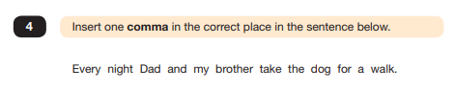

Week 3: 12/3/2026
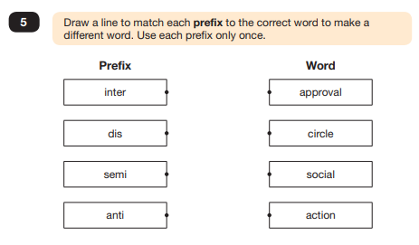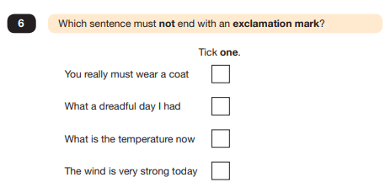
Week 4: 19/3/2026
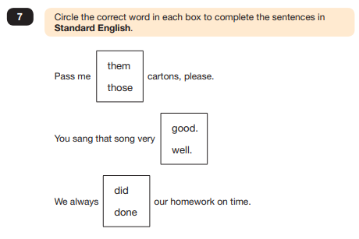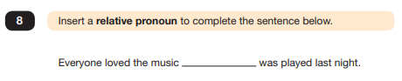

Week 5: 26/3/2026
