Special Educational Needs and Disabilities (SEND) Information Report


Inclusion Team
SEND Governor: Mrs Kelly Randell
SENCO: Mrs Liz Carter
Pastoral teacher:Mrs Clare Hudson
Contact details - office@crockenhill.kent.sch.uk
03000 658300
Approved by: |  | Date:

Contents
1. What types of SEND does the school provide for? 4
2. Which staff will support my child? 5
3. What should I do if I think my child has SEND? 7
4. What happens if the school identifies a need? 8
5. How will the school measure my child’s progress? 9
6. How will I be involved in decisions made about my child’s education? 10
7. How will my child be involved in decisions made about their education? 11
8. How will the school adapt its teaching for my child? 12
9. How will the school evaluate whether the support in place is helping my child? 13
10. How will the school ensure my child has appropriate resources? 13
11. How will the school make sure my child is included in activities alongside pupils who don’t have SEND? 14
12. How does the school make sure the admissions process is fair for pupils with SEN or a disability? 15
13. How does the school support pupils with disabilities? 15
14. How will the school support my child’s mental health and emotional and social development? 16
15. What support is in place for looked-after and previously looked-after children with SEN? 16
16. What support will be available for my child as they transition between classes or settings or in preparing for adulthood? 17
17. What support is available for me and my family? (Local Offer) 18
18. What should I do if I have a complaint about my child’s SEND support? 19
19. Supporting Documents…………………………………………………………………………………………………………….19
20. Glossary 20

Dear parents and carers,
The aim of this Information Report is to explain how we implement our SEND policy. In other words, we want to show you how SEND support works in our school.
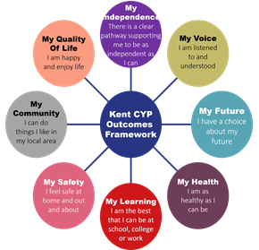
As educational professionals, we are all working towards the ultimate goal of growing independent young people as they prepare for adulthood. All provision and support we provide is working towards achieving the Kent Children and Young People (CYP) Outcomes Framework:

If you want to know more about our arrangements for SEND, read our SEND policy alongside this Information Report.
You can find our SEND policy on our website https://www.crockenhill.kent.sch.uk/policies/
Note: If there are any terms we’ve used in this information report that you’re unsure of, you can look them up in the Glossary at the end of the report.

1. What types of SEND does the school provide for?

Our school provides for pupils with the following needs (as outlined in the SEND Code of Practice 2015):

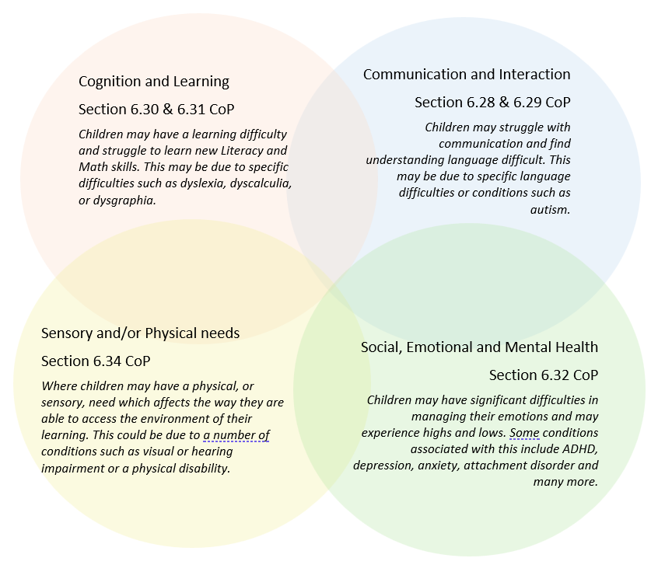

Often you will find that children’s needs overlap and are rarely confined to one area of need, which is why it is important to gain a wholistic overview of your child.
More information about the Areas of Need can be found in the Special educational needs and disability code of practice: 0 to 25 years (link below).
SEND_Code_of_Practice_January_2015.pdf (publishing.service.gov.uk)


2. Which staff will support my child, and what are their key responsibilities?

At Crockenhill Primary School all staff are considered responsible for supporting the needs of pupils with SEND. Our staff are committed to regular, high-quality training to ensure that they have the knowledge and skills to better meet a wide range of pupil needs.
Below outlines key staff who will be supporting your child. Please note that this list is not exhaustive.
Our Special Educational Needs Co-ordinator, or SENCO
The named SENCO is Mrs Liz Carter. They have 14 years experience in this role and have worked as a class teacher. Subject leader for over 20 years. They have Qualified teacher status.
They achieved the National Award in Special Educational Needs in 2012. Mrs Carter has also completed
an MA in Educational studies and has a PGCE in Primary Education.
Class/subject teachers
All of our teachers receive in-house SEN training, and are supported by the SENCO to meet the needs of pupils who have SEN.
Teachers have recently completed AET training to support children with Autism and are working on the recommended training to support the “Mainstream core standards for all pupils.”
Teaching assistants (TAs)
We have a team of 9 Teaching assistants, who are trained to deliver a variety of class and SEN provisions.
In the last academic year, TAs have worked alongside the teachers to complete the AET training. (Autism in Education Training)

External agencies
Sometimes we need extra help to offer our pupils the support that they need. Whenever necessary we will work with external support services to meet the needs of our pupils with SEND and to support their families. These may include:

- Child and adolescent mental health services (CAMHS)
- Education welfare officers
- Educational psychologists
- GPs or paediatricians
- NELFT practitioners
- Occupational therapists
- Therapeutic practitioners
- Safeguarding services
- School nurses
- SEND Inclusion Advisor
- Specialist Teacher Service
- Speech and language therapists



- Voluntary sector organisations

3. What should I do if I think my child has SEND?

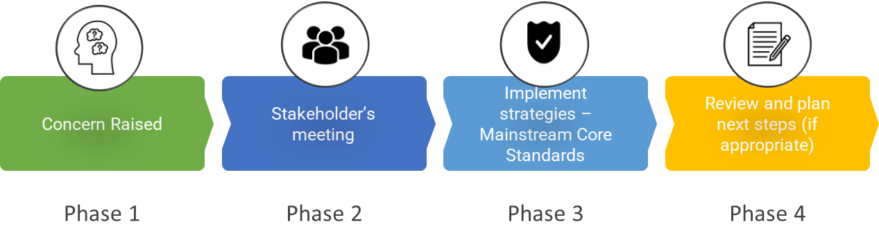

Phase 1 | If you think your child might have SEND, raise your concern with the school so that the SENCO is aware.  Please contact the class teacher via Class dojo or in person at Parents consultations.
Phase 2 | We will meet with you to discuss your concerns and try to get a better understanding of what your child’s strengths and difficulties are. Together we will decide what outcomes to seek for your child and agree on next steps. We will make a note of what’s been discussed and add this to your child’s record.
Phase 3 | We will implement the agreed strategies and monitor these over an agreed period of time. These are likely to be universal strategies set out in the mainstream core standards. A copy of this can be found here: https://www.kelsi.org.uk/__data/assets/pdf_file/0005/117257/Special-educational-needs-mainstream-core-standards-guide-for-parents.pdf . This will initiate the ‘Graduated Approach’ where support will be continually reviewed. See next page for more details.
Phase 4 | If we decide that your child needs SEND support, we will formally notify you and your child will be added to the school’s SEND register. They will receive additional support and this will be reviewed using the assess, plan, do, review model.

4. What happens if the school identifies a need?
The same process is followed if a concern is raised by the school.

All our class teachers are responsible for the monitoring of all pupils who have been identified as having SEND. They also review those who are not making the expected level of progress in their schoolwork or socially.
If the teacher notices that a pupil is having difficulties, they try to find out if the pupil has any gaps in their learning. If they can find a gap, the school will provide appropriate support. Pupils who don’t have SEND usually make progress quickly once the gap in their learning has been filled.
If the pupil is still finding it difficult to make the expected progress, the teacher will talk to the SENCO, and will contact you to discuss the possibility that your child has SEND, and the school will follow the graduated approach (see previous page).

5. How will the school measure my child’s progress?

We will follow the ‘graduated approach’ to meeting your child’s SEND needs.
The graduated approach is a 4-part cycle of assess, plan, do, review.
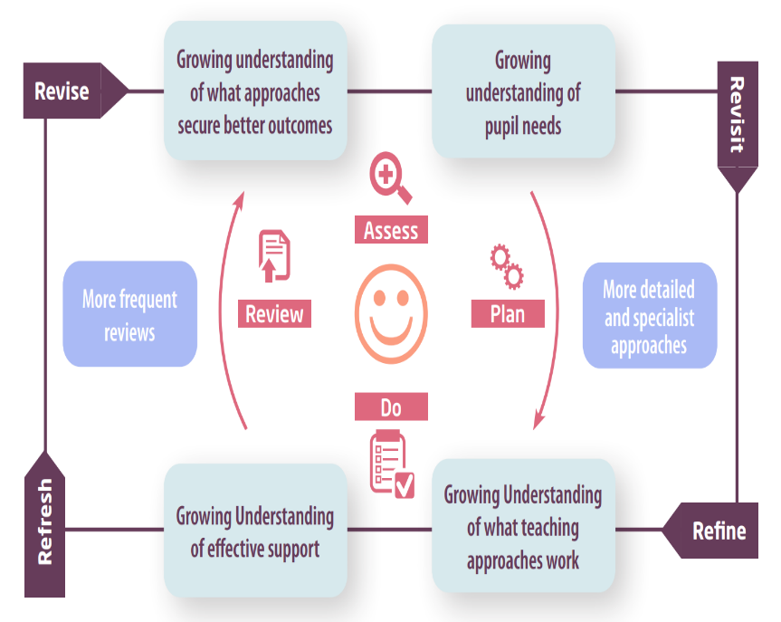

Assess | If your child is not making the expected level of progress, we will make an assessment to find out what strengths and difficulties your child has. We will ask for you and your child’s input, as well as getting help from external professionals where necessary.
Plan | In discussion with you and your child, we will decide what outcomes we are hoping to achieve. We will make a plan of the support we will offer your child to help them meet those outcomes. We will make a record of this and share it with you and all relevant school staff.
Do | We will put our plan into practice.  The class teacher, with the support of the SENCO, will be responsible for working with your child on a daily basis, and making sure the support we put in place is having the impact we intended.
Review | We will assess how well the support we put in place helped the pupil to meet the outcomes we set. We will use our improved understanding of your child’s needs to improve the support we offer; this may mean the Plan, Assess, Do, Review cycle continues.

6. How will I be involved in decisions made about my child’s education?

We will provide written reports on your child's progress annually.
A member of staff who knows your child well will meet with you two – three times a year, to you:
- Set clear outcomes for your child’s progress
- Review progress towards those outcomes
- Discuss the support we will put in place to help your child make that progress
- Identify what we will do, what we will ask you to do, and what we will ask your child to do

The SENCO may also attend these meetings to provide extra support.
We know that you’re the expert when it comes to your child’s needs and aspirations. So, we want to make sure you have a full understanding of how we’re trying to meet your child’s needs, so that you can provide insight into what you think would work best for your child.
We also want to hear from you as much as possible so that we can build a better picture of how the SEND support we are providing is impacting your child outside of school.
If your child’s needs or aspirations change at any time, please let us know right away so we can keep our provision as relevant as possible.
If you have concerns that arise between these meetings, please contact the class teacher through Class dojo or contact the SENCo - office@crockenhill.kent.sch.uk

7. How will my child be involved in decisions made about their education?

The level of involvement will depend on your child’s age and individual needs. We recognise that no two pupils are the same, so we will decide on a case-by-case basis, with your input.

We may seek your child’s views by asking them to:
- Attend meetings to discuss their progress and outcomes
- Prepare a presentation, written statement, video, drawing, etc.
- Discuss their views with a member of staff who can act as a representative during the meeting
- Complete a survey



8. How will the school adapt its teaching for my child?

Your child’s teacher/s are responsible and accountable for the progress and development of all the pupils in their class.
High-quality teaching is our first step in responding to your child’s needs. We will make sure that your child has access to a broad and balanced curriculum in every year they are at our school.
We will adapt our approaches to how we teach to suit the way the pupil works best. There is no 'one size fits all’ approach to adapting the curriculum, we work on a case-by case basis to make sure the adaptations we make are meaningful to your child and are guided by the Mainstream Core Standards in the first instance.
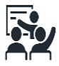
These adaptations may include:
- Adapting our approaches, for example, giving longer processing times, pre-teaching of key vocabulary, reading instructions aloud, etc.

- Adapting our resources and staffing

- Using recommended aids, such as laptops, coloured overlays, visual timetables, larger font, etc.

- Teaching assistants or support staff will support pupils appropriately depending on their presentation of need

- Scaffolding lesson materials
We may also provide the following interventions:
- Focus Maths or English intervention sessions with a TA or Pupil premium teacher
- Toe by Toe
- Power of 1 / 2
- Specific Speech and Language development sessions
- Fine motor skills support group
- Gross motor skills support group
These interventions are part of our contribution to Kent County Council’s local offer.

9. How will the school evaluate whether the support in place is helping my child?

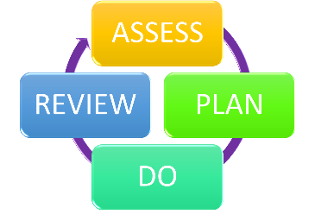
We will evaluate the effectiveness of provision for your child by:
- Reviewing their progress towards their goals each term through pupil progress meetings
- Reviewing the impact of interventions after 6 – 8 weeks
- Using pupil questionnaires
- Monitoring by the SENCO
- Using provision maps to measure progress
- Holding an annual review (if they have an education, health and care (EHC) plan)

10. How will the school ensure my child has appropriate resources?

It may be that your child’s needs mean we need to provide additional resources such as:
- Additional resources to support their learning
- Adaptations to in class support
- Further training for our staff
- External specialist expertise
Where appropriate, we will consult with external agencies to get recommendations on what will best help your child access their learning and use our best endeavours to ensure these are supplied.

11. How will the school make sure my child is included in activities alongside pupils who don’t have SEND?


The expectation is that all schools providing an inclusive provision for all pupils. It may be necessary for some pupils to receive interventions in addition to a broad and balanced curriculum.
All of our extra-curricular activities and school visits are available to all our pupils, including our before and after-school clubs.
All pupils are encouraged to go on our school trips, including our residential trip(s) in years 5 and 6.
All pupils are encouraged to take part in sports day and whole school events, if through discussion with class teachers and parents, it is felt that it is appropriate.
No pupil is ever excluded from taking part in these activities because of their SEN or disability and we will make whatever reasonable adjustments are needed to make sure that they can be included.

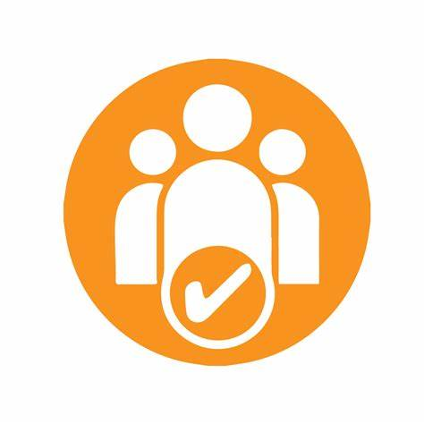
12. How does the school make sure the admissions process is fair for pupils with SEN or a disability?

- We will follow the KCC guidance for admission of all pupils.
- Children with an EHCP will be given priority admission if space allows.
- Careful consideration will be given for a pupil with a disability or special educational need, when a placement request results in the oversubscription of classes.

13. How does the school support pupils with disabilities?


You’re disabled under the Equality Act 2010 if you have a physical or mental impairment that has a ‘substantial’ and ‘long-term’ negative effect on your ability to do normal daily activities.
See accessibility plan - https://www.crockenhill.kent.sch.uk/policies/

14. How will the school support my child’s mental health and emotional and social development?
We provide support for pupils to progress in their emotional and social development in the following ways:
- Pupils with SEND are encouraged to be part of the school council
- We provide extra pastoral support for listening to the views of pupils with SEND by the pastoral teacher, counsellor or wellbeing team.
- We have a ‘zero tolerance’ approach to bullying.

15. What support is in place for looked-after and previously looked-after children with SEND?


Mrs Liz Carter, our SENCO, to make sure that all teachers understand how a looked-after or previously looked-after pupil’s circumstances and their SEND might interact, and what the implications are for teaching and learning.
Pupils who are looked-after or previously looked-after will be supported much in the same way as any other child who has SEND. However, looked-after pupils will also have a personal education plan (PEP). We will make sure that the PEP and any SEND support plans or EHC plans are consistent and complement one another.

16. What support will be available for my child as they transition between classes or settings or in preparing for adulthood?

Between years

To help pupils with SEND be prepared for a new school year we:
- Teachers will meet towards the end of term to share the support and provision in place for specific individuals.
- The current teacher will provide the new teacher with a provision plan with recommended support and interventions.
- Plan 2-3 meet the teacher sessions where the child can visit the class and get to know the new team.
- Plan for additional visits if necessary depending on the individuals needs.
- Allow parents and children to visit the new classroom and meet the teacher (where possible) before the end of term.
- Provide some children with a social story to read over the summer, preparing them for the changes in the following year
Between schools
When your child is moving on from our school, we will ask you and your child what information you want us to share with the new setting.
A transition form will be completed by the classteacher and this is shared with the Secondary School.
The SENCo of the Secondary school will make contact with the year 6 teacher and the SENCo to discuss the needs of all the pupils who are receiving SEND support.
Pupils moving on will be encouraged to attend the transition visits arranged by the new school. Children with identified SEN or who are vulnerable may be put forward for additional visits and in some cases have access to summer school, to help them prepare.
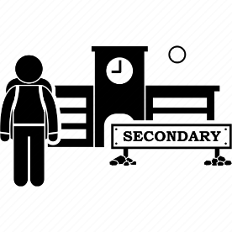
Pupils will be prepared for the transition by:
- Practising with a secondary school timetable
- Learning how to get organised independently
- Be given opportunities to ask questions and raise concerns about the transition.

17. What support is available for me and my family?
If you have questions about SEND, or are struggling to cope, please get in touch to let us know. We want to support you, your child and your family.
To see what support is available to you locally, have a look at KCC’s local offer. KCC publishes information about the local offer on their website:
https://www.kent.gov.uk/education-and-children/special-educational-needs/about-the-send-local-offer
Our local special educational needs and disabilities information advice and support services (SENDIASS) organisations are:
https://local.kent.gov.uk/kb5/kent/directory/service.page?id=q8eJOMCAQOI&localofferchannel=2
National charities that offer information and support to families of pupils with SEND are:
- IPSEA
- SEND family support
- NSPCC
- Family Action
- Special Needs Jungle

18. What should I do if I have a complaint about my child’s SEND support?
Please see the school complaints policy to find out more information –
https://www.crockenhill.kent.sch.uk/policies/
Complaints about SEND provision in our school should be made to the headteacher in the first instance. They will then be referred to the school’s complaints policy.
If you are not satisfied with the school’s response, you can escalate the complaint. In some circumstances, this right also applies to the pupil themselves.
To see a full explanation of suitable avenues for complaint, see pages 246 and 247 of the SEND Code of Practice.
If you feel that our school discriminated against your child because of their SEND, you have the right to make a discrimination claim to the first-tier SEND tribunal. To find out how to make such a claim, you should visit: https://www.gov.uk/complain-about-school/disability-discrimination
You can make a claim about alleged discrimination regarding:
- Admission
- Exclusion
- Provision of education and associated services
- Making reasonable adjustments, including the provision of auxiliary aids and services
Before going to a SEND tribunal, you can go through processes called disagreement resolution or mediation, where you try to resolve your disagreement before it reaches the tribunal.
https://local.kent.gov.uk/kb5/kent/directory/service.page?id=5zPMmea4PNM&adultchannel=7

19. Supporting documents

- Equality Information and Objectives Policy
- Child protection and safeguarding policy
- Behaviour Policy
- Accessibility Plan
- Attendance and punctuality policy
- SEND policy

- SEN & Disabilities Code Of Practice 2015
- Mainstream Core Standards

20. Glossary
- Access arrangements – special arrangements to allow pupils with SEND to access assessments or exams
- Annual review – an annual meeting to review the provision in a pupil’s EHC plan
- Area of need – the 4 areas of need describe different types of needs a pupil with SEND can have. The 4 areas are communication and interaction; cognition and learning; physical and/or sensory; and social, emotional and mental health needs.
- CAMHS – child and adolescent mental health services
- Differentiation – when teachers adapt how they teach in response to a pupil’s needs
- EHC needs assessment – the needs assessment is the first step on the way to securing an EHC plan. The local authority will do an assessment to decide whether a child needs an EHC plan.
- EHC plan – an education, health and care plan is a legally-binding document that sets out a child’s needs and the provision that will be put in place to meet their needs.
- First-tier tribunal/SEND tribunal – a court where you can appeal against the local authority’s decisions about EHC needs assessments or plans and against discrimination by a school or local authority due to SEND
- Graduated approach – an approach to providing SEND support in which the school provides support in successive cycles of assessing the pupil’s needs, planning the provision, implementing the plan, and reviewing the impact of the action on the pupil
- Intervention – a short-term, targeted approach to teaching a pupil with a specific outcome in mind
- Local offer – information provided by the local authority which explains what services and support are on offer for pupils with SEND in the local area
- Outcome – target for improvement for pupils with SEND. These targets don't necessarily have to be related to academic attainment
- Reasonable adjustments – changes that the school must make to remove or reduce any disadvantages caused by a child’s disability
- SENCO – the special educational needs co-ordinator
- SEN – special educational needs
- SEND – special educational needs and disabilities
- SEND Code of Practice – the statutory guidance that schools must follow to support pupils with SEND
- SEND information report – a report that schools must publish on their website, that explains how the school supports pupils with SEND
- SEND support – special educational provision which meets the needs of pupils with SEND
- Transition – when a pupil moves between years, phases, schools or institutions or life stages

